ANISH SURESH BUTLE

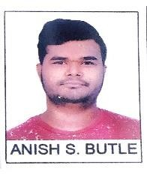

**Second year**

**Electronics & TelecommunicationEngineering Sinhgad College of Engineering**, **Pune** - **411041**

**Phone** : +**91** – **8605202273**

**Email** : [**anishbutle99@gmail.com**](mailto:anishbutle99@gmail.com) **Address** : **Chunna Bhatti Ward Rajura.**

**PIN CODE : 442905.**

TRisangaon

# Career Objective

Looking for a chance in a company that helps me give my absolute best and enhance my abilities.

# Educational Qualification

2021-22

2020

2018

Sinhgad College of Engineering, Pune

Bachelor of Engineering, Electronics & Telecommunication Engineering

12th (Senior Secondary Examination) Maharashtra Board of Secondary Education

10th (Secondary Examination)

Central Board of Secondary Education

Third Year

83.60%

78%

# Technical skills Python, Basics Java, C++, Basics HTML.

# Internship Oasis Infotech from 1 Feb to 28 Feb 2023

# 

**Academic Projects**

Automatic street light controller using Arduino.

**SoftSkills**

Time management, Communication skill.

# Personal Information

**Strengths**

**Hobbies**

Teamwork, detail oriented and can work with patience.

Singing, Reading Books, Gaming.

**Anish S. Butle**